# ### 1. s1s2 trans count (within & between PI), succession broad

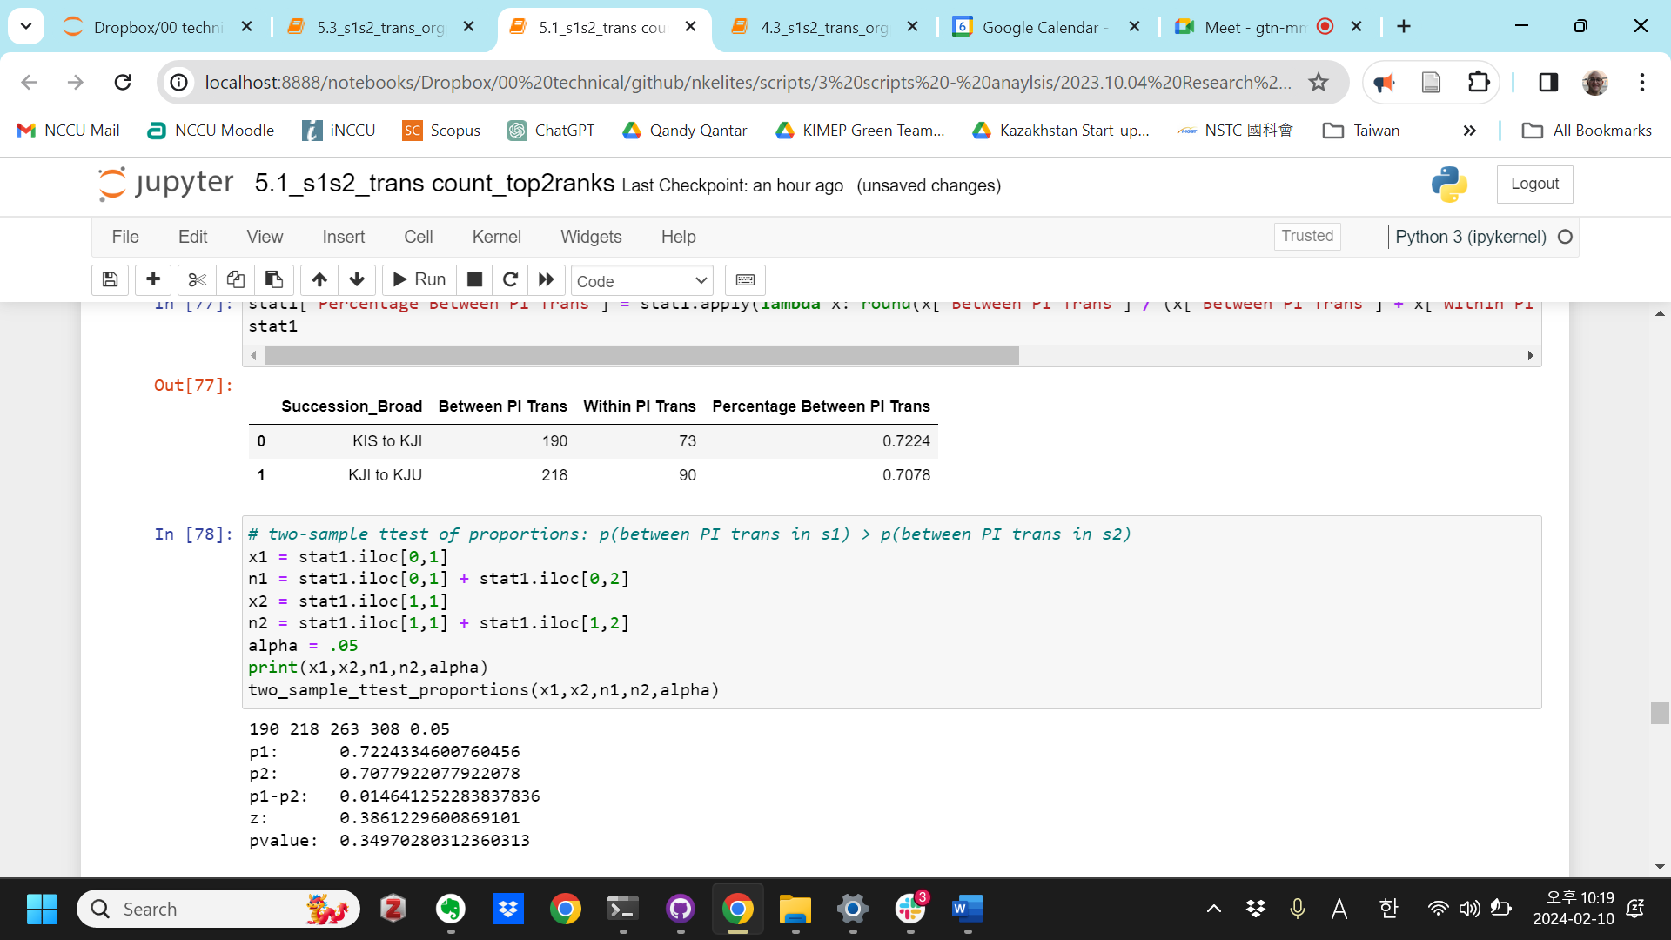

# ### 2. s1s2 trans count (within & between PI), succession narrow

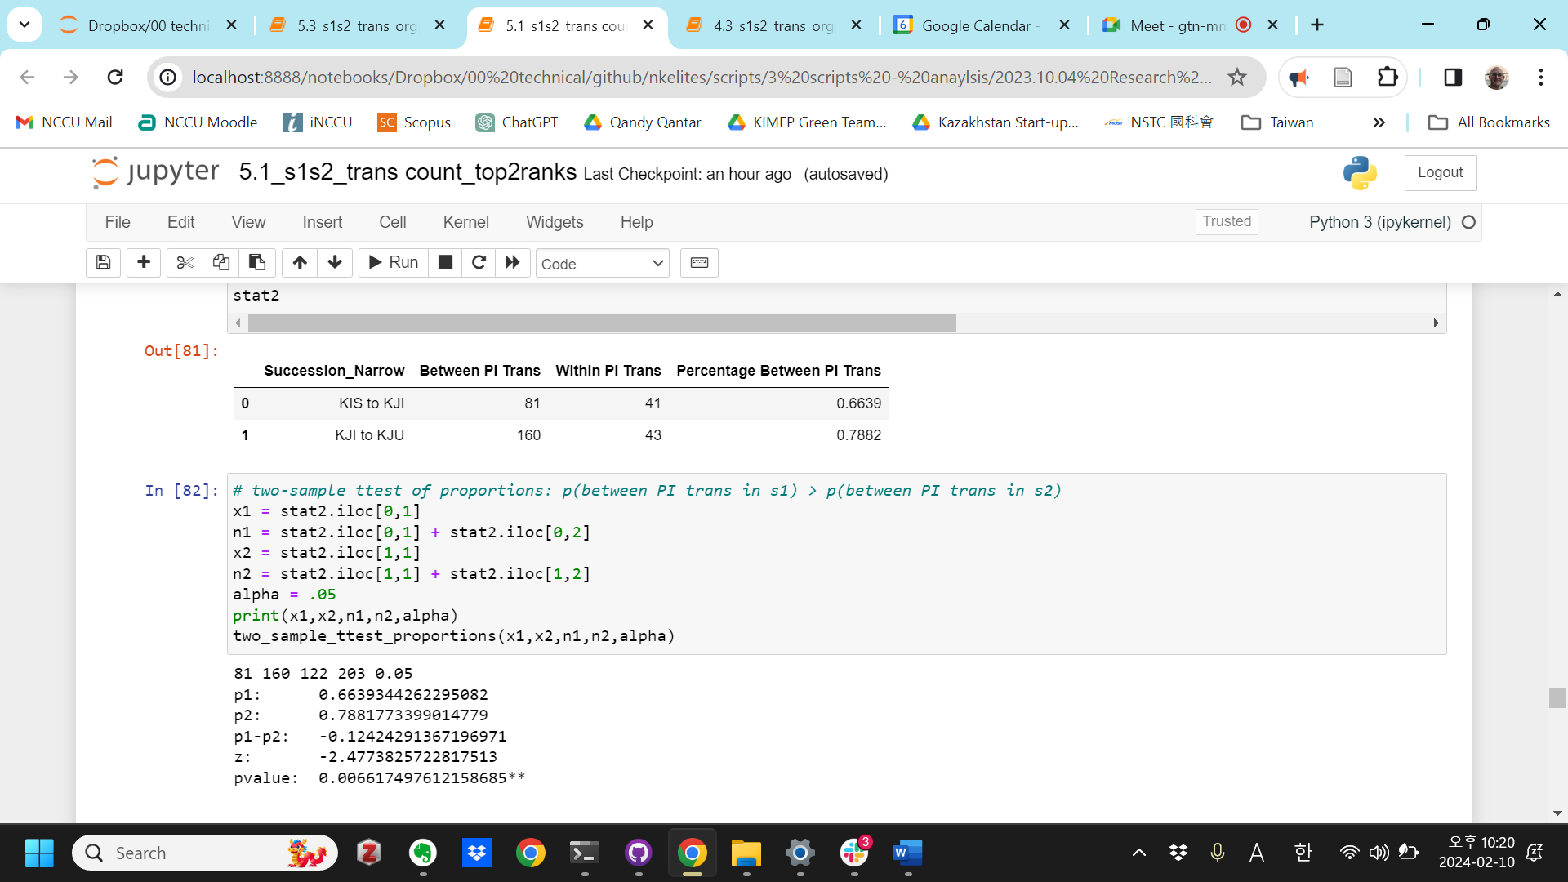

# ### 3. s1s2 trans count (within & between PI), succession broad, by sending PI

Government

71 65 108 140 0.05

p1: 0.6574074074074074

p2: 0.4642857142857143

p1-p2: 0.19312169312169314

z: 3.0300816457868387

pvalue: 0.0012224381847967258**

Social

77 92 86 104 0.05

p1: 0.8953488372093024

p2: 0.8846153846153846

p1-p2: 0.01073345259391778

z: 0.23487086031197224

pvalue: 0.40715448353707107

Party

24 9 50 9 0.05

p1: 0.48

p2: 1.0

p1-p2: -0.52

z: -2.8926238482168274

pvalue: 0.00191019264628145**

Military

18 52 19 55 0.05

p1: 0.9473684210526315

p2: 0.9454545454545454

p1-p2: 0.00191387559808609

z: 0.031805973636855445

pvalue: 0.4873133913873938

# ### 4. s1s2 trans count (within & between PI), succession narrow, by sending PI

Government

25 50 50 89 0.05

p1: 0.5

p2: 0.5617977528089888

p1-p2: -0.061797752808988804

z: -0.7015190513455424

pvalue: 0.241489574744294

Social

41 53 43 54 0.05

p1: 0.9534883720930233

p2: 0.9814814814814815

p1-p2: -0.027993109388458226

z: -0.7911221823627147

pvalue: 0.21443634794698374

Party

12 9 25 9 0.05

p1: 0.48

p2: 1.0

p1-p2: -0.52

z: -2.752661050173606

pvalue: 0.0029556531624868043**

Military

3 48 4 51 0.05

p1: 0.75

p2: 0.9411764705882353

p1-p2: -0.19117647058823528

z: -1.4178026519447586

pvalue: 0.07812419485736677

# ### 5. s1s2 trans count (within & between PI), succession broad, by receiving PI

Government

72 69 109 144 0.05

p1: 0.6605504587155964

p2: 0.4791666666666667

p1-p2: 0.18138379204892968

z: 2.8763032040275616

pvalue: 0.002011815036797704**

Social

27 24 36 36 0.05

p1: 0.75

p2: 0.6666666666666666

p1-p2: 0.08333333333333337

z: 0.7778444682625976

pvalue: 0.21833035452449723

Party

86 110 112 110 0.05

p1: 0.7678571428571429

p2: 1.0

p1-p2: -0.2321428571428571

z: -5.378020542566587

pvalue: 3.765461276117321e-08***

Military

5 15 6 18 0.05

p1: 0.8333333333333334

p2: 0.8333333333333334

p1-p2: 0.0

z: 0.0

pvalue: 0.5

# ### 6. s1s2 trans count (within & between PI), succession narrow, by receiving PI

Government

39 31 64 70 0.05

p1: 0.609375

p2: 0.44285714285714284

p1-p2: 0.16651785714285716

z: 1.9275835556878367

pvalue: 0.026953472949736046*

Social

13 8 15 9 0.05

p1: 0.8666666666666667

p2: 0.8888888888888888

p1-p2: -0.022222222222222143

z: -0.1593638145779186

pvalue: 0.43669112315483205

Party

23 110 36 110 0.05

p1: 0.6388888888888888

p2: 1.0

p1-p2: -0.36111111111111116

z: -6.603396508384963

pvalue: 2.0092150165851308e-11***

Military

6 11 7 14 0.05

p1: 0.8571428571428571

p2: 0.7857142857142857

p1-p2: 0.0714285714285714

z: 0.39295262399668773

pvalue: 0.3471772365152276

In [ ]: